1. 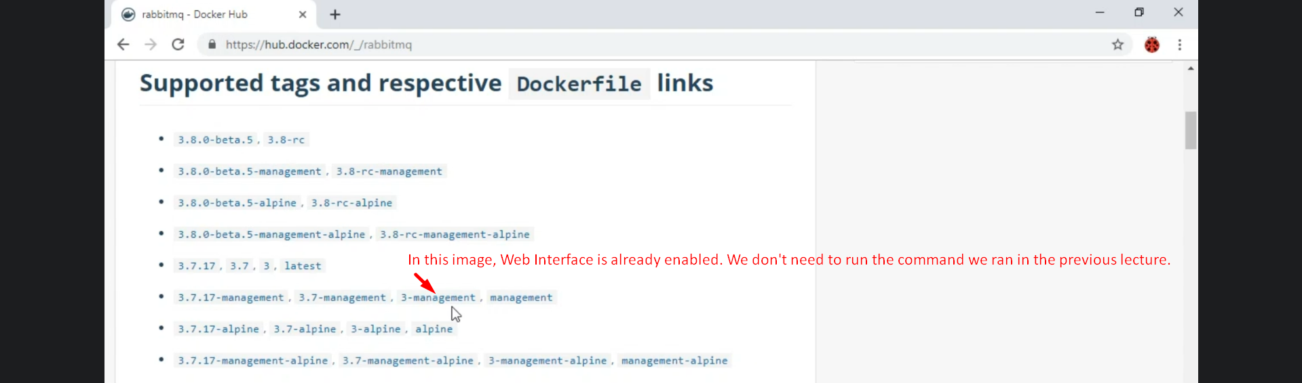
2. 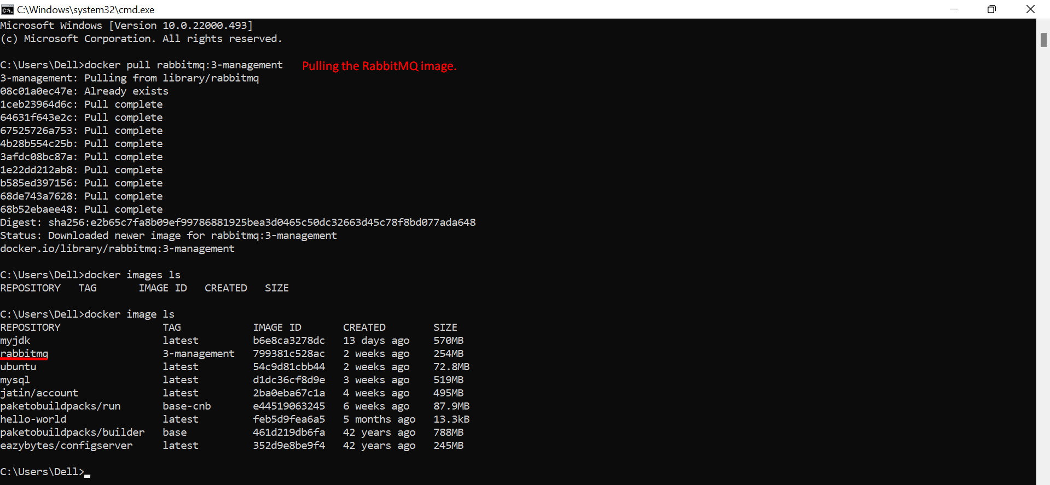
3. 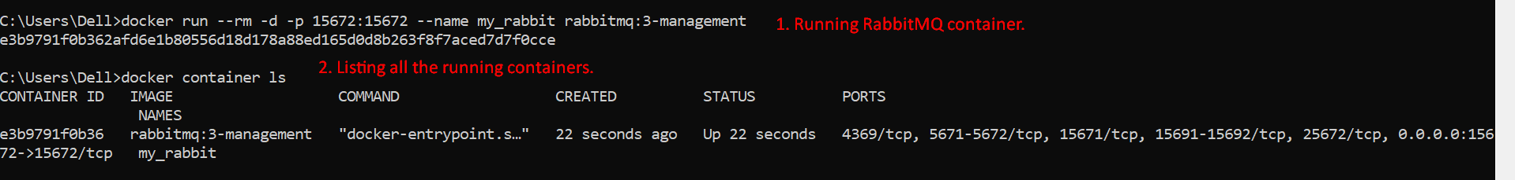
4. 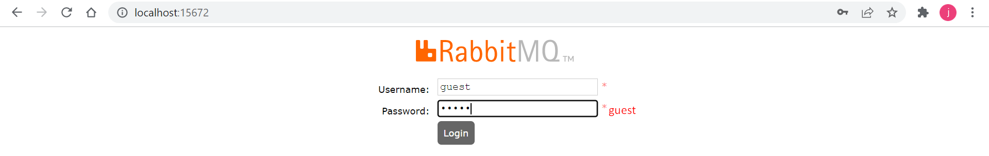
5. The above app is “Management Web Interface” for RabbitMQ.